Technical Coding Research Innovation(TCR),Navi Mumbai

(Maharastra)



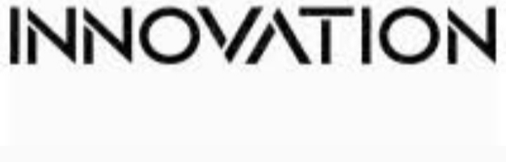

Backend Web Development Internship Program

**Project File on**

Library Management System

Certificate Code:-**.. TCRID3R87………….**

Group:- Own

Submitted to:- Submitted By:-

TCR innovation Name:- Diya Bhargava

Team Submission date:-30/10/22

Sign…………………………………………

Research Paper:

Abstract:

This Python Django library management system project is primarily concerned with the distribution of books and records. The system also shows all of the students who are available ,along with their issued books. The system also allows you to manage your books by entering a title , author ,ISBN, and category .There are two sections to this project: Admin Panel and Fines The system administrator ,on the other hand, has the primary responsibility .An administrator can easily add and view all of the accessible book records .An administrator can issue books to students by selecting a book and available pupils. The approach provides for the distribution of a set number of books to each student. Student Panel Admin Panel Add Books List Books Issue Books View Issued Books.

Objectives:

In order to analyse the existing system, following objectives are set:

• To understand the existing system, to go through old websites and writing down the detailed scenario.

• To determine the Library requirements.

• To determine the INPUT and OUTPUT requirements.

• To determine the problems and recommend the solution.

Scope:

This software is required for:

• More attractive and professional touch.

• Database accessing facility.

• More dynamic information will be provided.

• Easy retrieval and access of the information about every department of trade.

• All things should be connected to each other.

Benefits:

The following are the main benefits of the proposed software-

• Easy maintenance of the information.

• Save time and human efforts.

• Eases task of searching.

DESIGN:

Data Flow Diagram:

Library Management System:

Output:

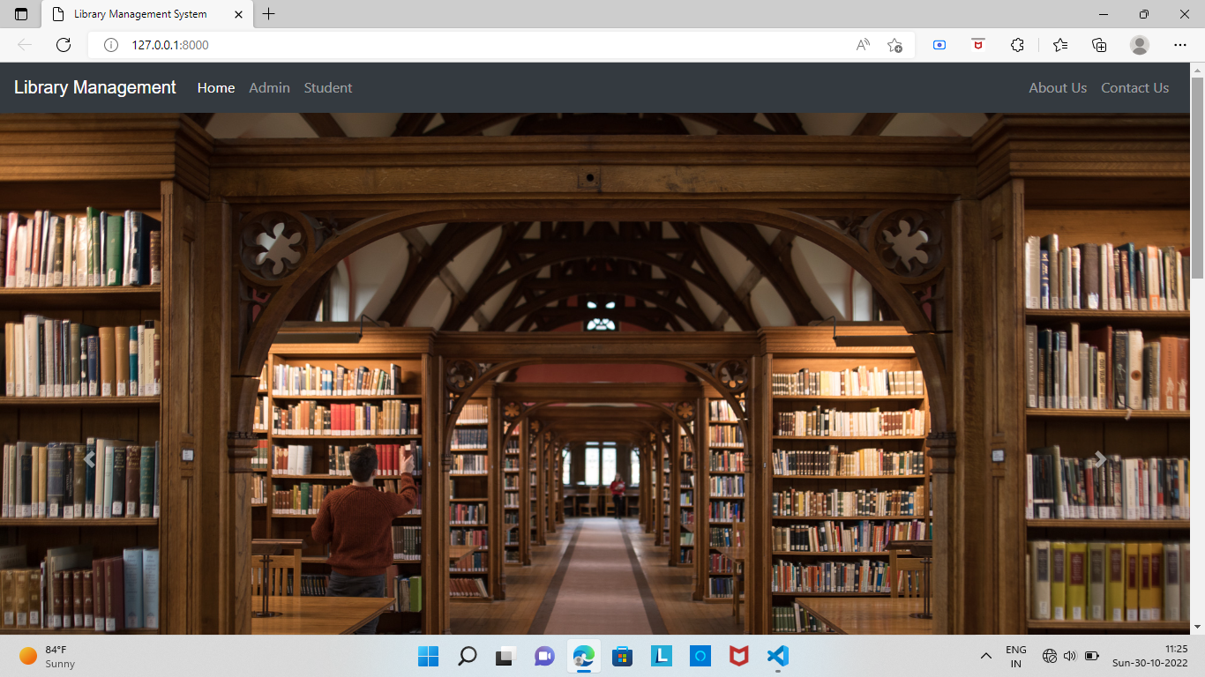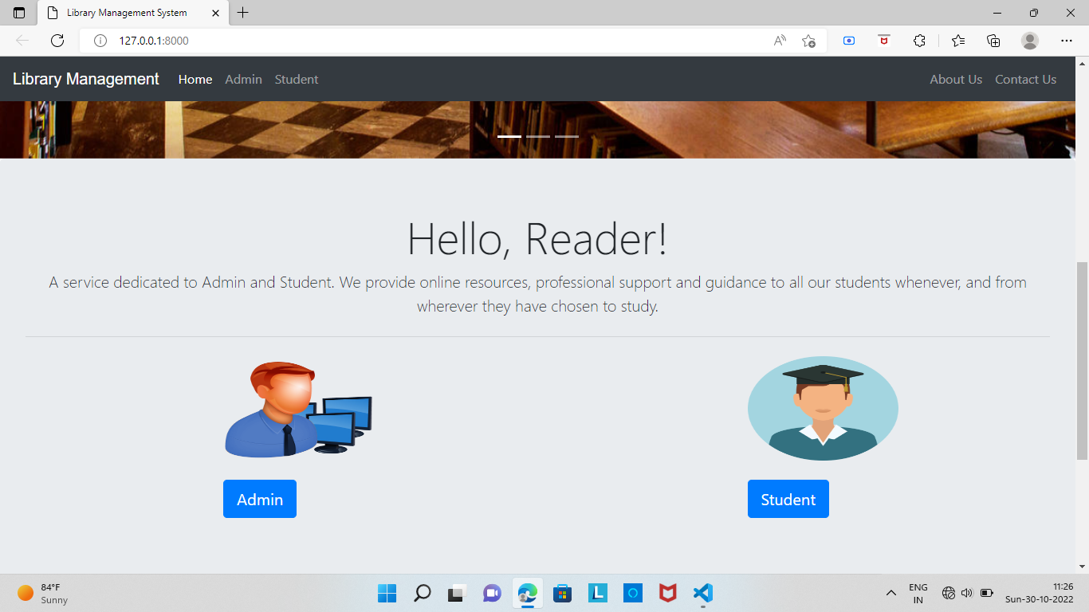

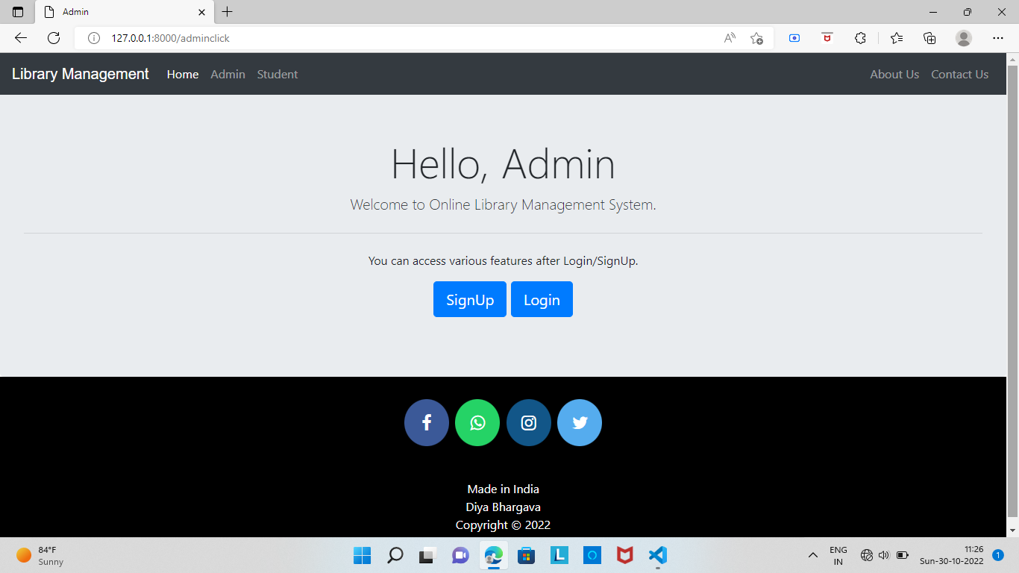

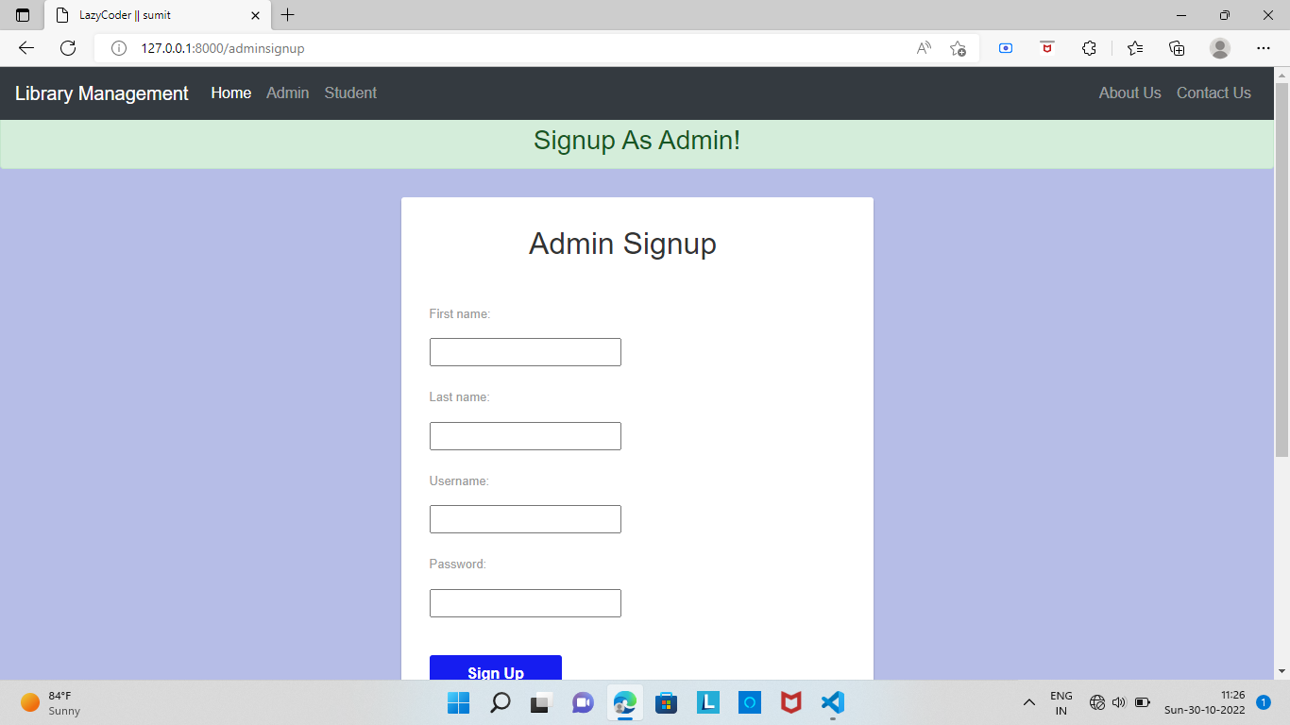

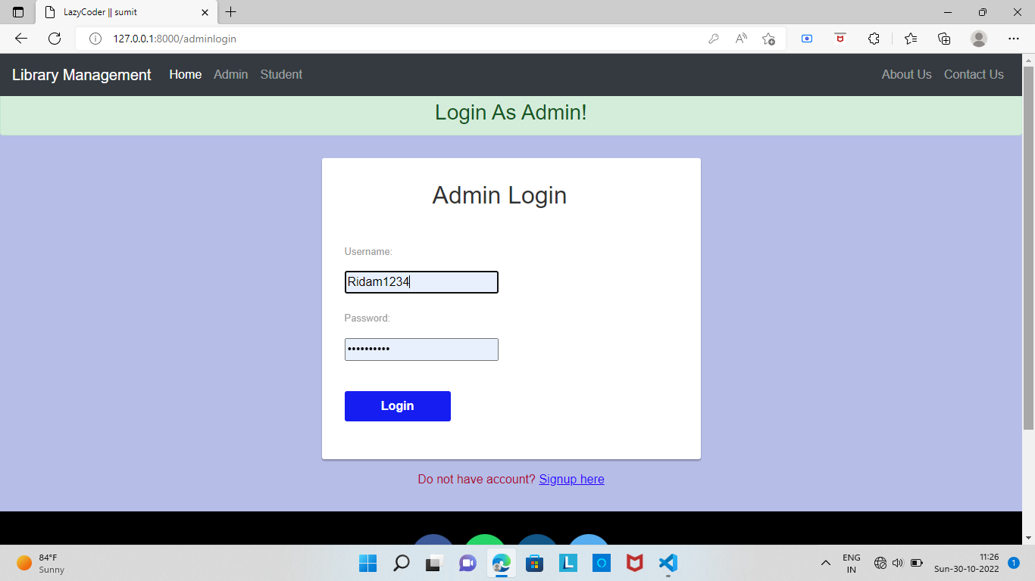

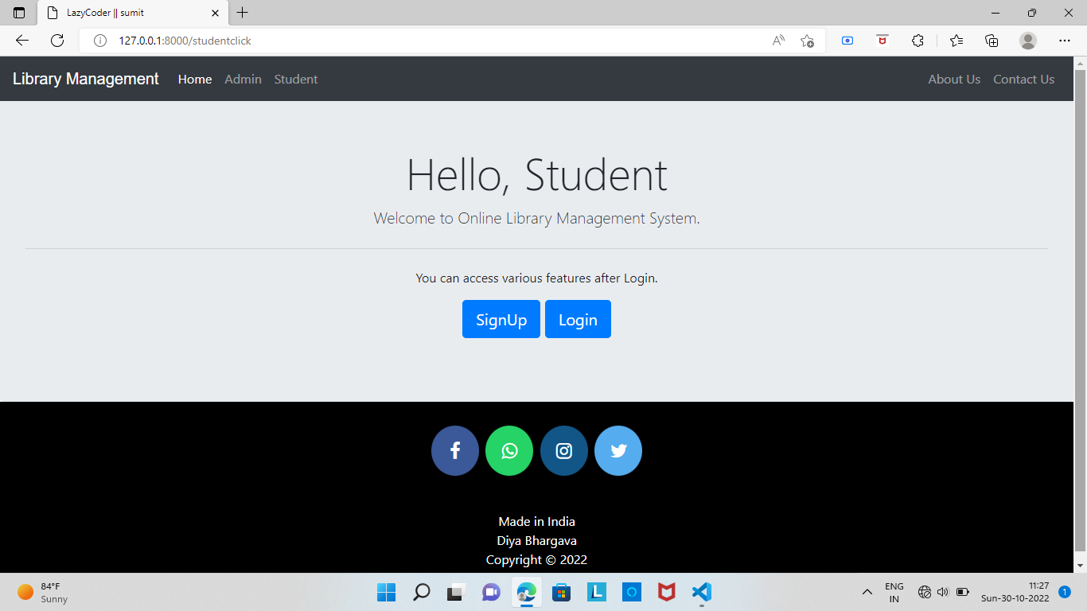

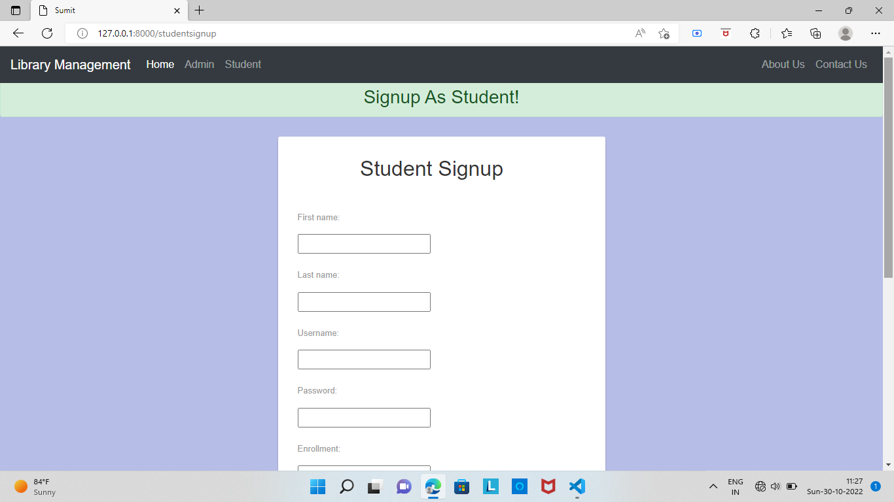

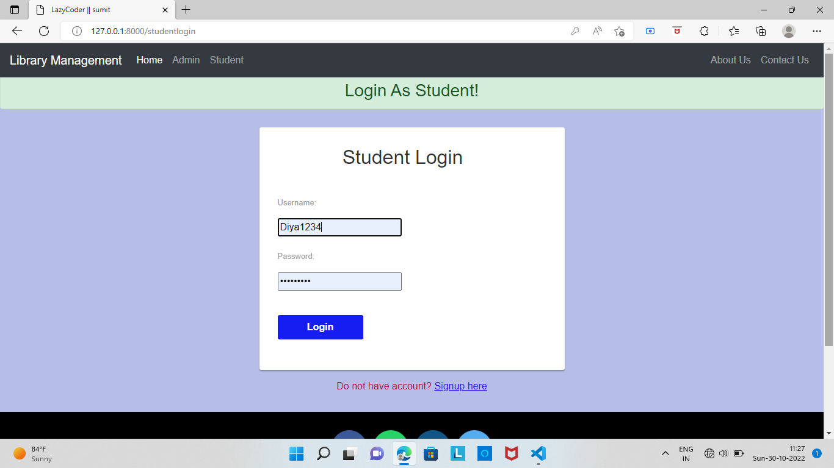

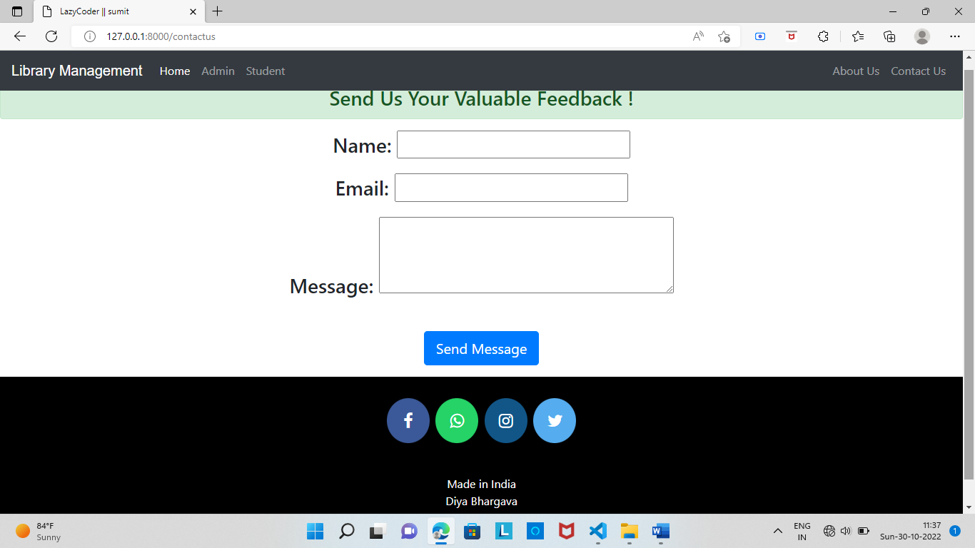

0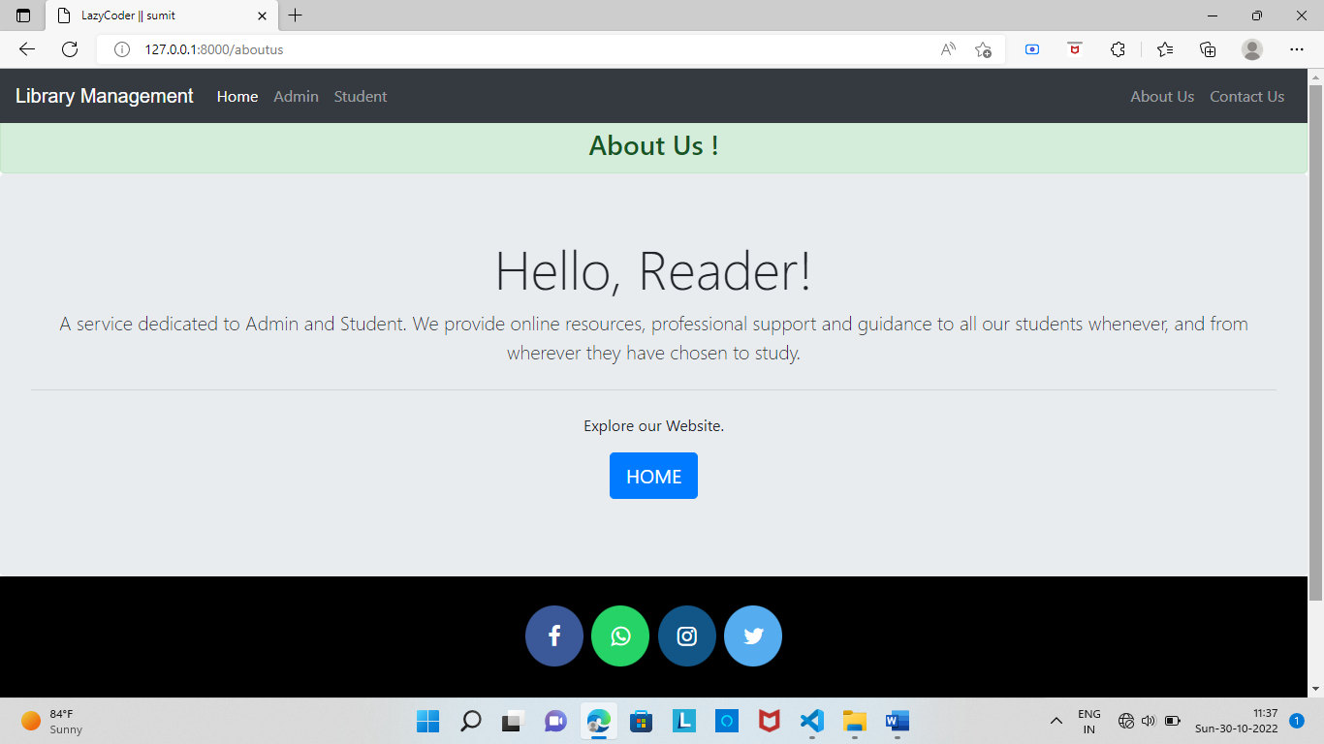

Code: -

